ГБУ ДППО ЦПКС «ИМЦ» Василеостровского района
Районная диагностическая работа. 6 класс. (45 минут + инструктаж)

- (1-5) Look at the map, read the directions and find the place. Write the name of the place in the gaps. There is an example (0).
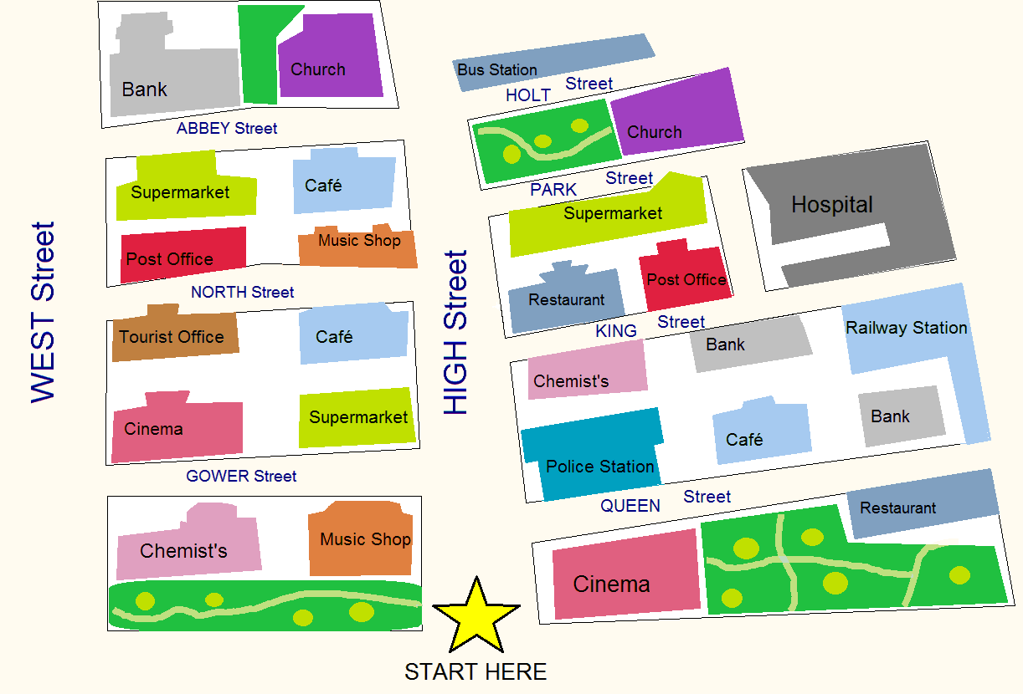
- Go straight ahead. Take the first right. Go to the end of Queen Street. It’s opposite the bank.
…………..Restaurant…………………

- Go straight ahead. Take the second left. Walk about 100 meters. It’s next to the music shop.
…………………………………
- Go straight ahead. Take the third right. Go past the park. It’s on your left.
………………………………………..
- Go straight ahead. Take the first left. Go to the end of the street. It’s on the corner of West Street – opposite the chemist’s.
…………………………………………
- Go straight ahead. Take the third left. It’s at the end of the street – on the right, opposite the supermarket.
………………………………………..
- Go straight ahead. Take the second right. Go past the bank. Turn left. It’s on your right.
……………………………………..
(max.10 points)

- (6-11) Read the article about a young man and a woman who lost a ring. Are the sentences True or False? There is an example (0)
THE RING AND THE FISH
Thomas and Inger, who live in Sweden, are the happiest couple in the world. Two years ago, they were on boat a few kilometers from the beach. Thomas asked Inger to marry him and he gave her a golden ring. He wanted to put the ring on Inger’s finger, but he dropped it and it fell into the sea. They were sure the ring was lost forever.
That is, until last week, when Mr Carlsson visited them. He has a fish shop and he found the ring in a large fish which he was cutting up for one of his customers. The fish thought the ring was something to eat! Mr Carlsson knew that the ring belonged to Thomas and Inger because inside the ring there were some words. They were, “To Inger, All my love, Thomas’. And so Mr Carlsson gave the ring back to them.
Inger now has two rings. When they lost the first one, Thomas bought her another one. But they think the one the fish ate is the best one.

- Thomas asked Inger to marry him when they were on a boat. True / False
- Thomas put the gold ring on Inger’s finger. True / False
- They returned from their boat trip without a ring. True / False
- Mr Carlsson visited Thomas and Inger last month. True / False
- Mr Carlsson caught the fish. True / False
- Mr Carlsson found the ring when he ate the fish. True / False
- Thomas and Inger prefer the first ring. True / False
(max. 6 points)
3 (12). Match the titles (1-5) to the texts (A-D). There is one extra title.
1. A National Dish
Text | A | B | C | D
Title
2. A Daily Menu
3. A Healthy Snack
4. A Good Start
5. An Unhealthy Food
A. Breakfast is a very important meal. If you have it at home, choose milk, yoghurt, fresh fruit and cereal. These low-fat foods can give you energy for the whole day. They also contain a lot of vitamins and minerals you need. Children who eat a healthy breakfast study better. They are more active, creative, and concentrate better all day long.
B. You can get hungry at school between meals or classes. So what should you do? Instead of a sandwich on white bread, a bag of chips, and cookies try to have something healthier. For example, some low-fat yoghurt, nuts or a whole-grain sandwich with lean meat. It is also better to have water and not juice, because most juices are full of sugar.
C. Gazpacho is a cold tomato soup typical of the south of Spain. It originated there. In cities like Seville and Cordoba summer temperatures are over plus 38°C and gazpacho is the best choice for cooling down quickly. There are various versions of gazpacho all over Spain, but the basic ingredients are tomatoes, cucumbers, onions and olive oil. Other gazpacho recipes include pepper, bread, garlic and vinegar.
D. French fries are full of salt and calories. Even a small serving from popular fast food cafes contains about 350 calories. And this leads to putting on weight. What’s more, French fries are loaded with fat. Frying robs the vegetables of their natural nutritional value. To make matters worse, many restaurants prepare fried foods using unhealthy artificial oils that contain bad fats. (max.4 points)

